MOHAMED HANIF S
192424158

1)Write a program that takes an input list of n numbers and creates a new list containing only the unique elements from the original list. What is the space complexity of the algorithm?

n = int(input("Enter the number of elements: "))
a = []

for i in range(n):
a.append(int(input("Enter number: ")))
unique = []
for i in a:
if i not in unique:
unique.append(i)

print("Unique elements:", unique)

Output

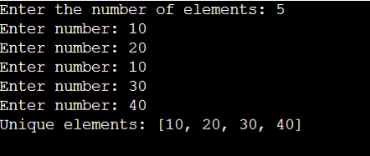

2) Sort an array of integers using the bubble sort technique. Analyze its time complexity using Big-O notation. Write the code

n = int(input("Enter number of elements: "))
a = []

for i in range(n):
a.append(int(input("Enter element: ")))

for i in range(n - 1):
for j in range(n - 1 - i):
if a[j] > a[j + 1]:
a[j], a[j + 1] = a[j + 1], a[j]

print("Sorted array:", a)
Output

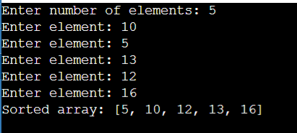

3)Checks if a given number x exists in a sorted array arr using binary search. Analyze its time complexity using Big-O notation.

n = int(input("Enter number of elements: "))
arr = []

for i in range(n):
arr.append(int(input("Enter element: ")))

x = int(input("Enter number to search: "))

low = 0
high = n - 1
found = False

while low <= high:
mid = (low + high) // 2

if arr[mid] == x:
found = True
break
elif arr[mid] < x:
low = mid + 1
else:
high = mid - 1

if found:
print("Element found")
else:
print("Element not found")

Output

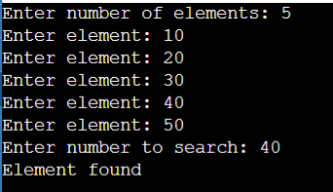

4) Given an array of integers nums, sort the array in ascending order and return it. You must solve the problem without using any built-in functions in O(nlog(n)) time complexity and with the smallest space complexity possible.

def merge_sort(arr):
if len(arr) <= 1:
return arr

mid = len(arr) // 2

left = merge_sort(arr[:mid])
right = merge_sort(arr[mid:])

result = []
i = 0
j = 0

while i < len(left) and j < len(right):
if left[i] <= right[j]:
result.append(left[i])
i += 1
else:
result.append(right[j])
j += 1

while i < len(left):
result.append(left[i])
i += 1

while j < len(right):
result.append(right[j])
j += 1

return result

n = int(input("Enter number of elements: "))
nums = []

for i in range(n):
nums.append(int(input("Enter element: ")))

nums = merge_sort(nums)

print("Sorted array:", nums)

Output
